|  |  |
| --- | --- |
|  | **LDCW6123 FUNDAMENTALS OF DIGITAL COMPETENCE FOR PROGRAMMERS**  Trimester July/August 2024 |

**PROJECT**

**Lecturer : Ts Dr. Muhammad Arif bin Hasan**

**Group : L1**

*Prepared by:*

|  |  |  |
| --- | --- | --- |
| **Student ID** | **Student Name** | **Phone number** |
| 241UE24127 | See Zi Ling | 012-6315996 |
| 241UE2412J | Lum Yong Kai | 017-7121290 |
| 241UE24126 | Tan Lee Jin Xiang | 014-3362772 |
| 242UE2448W | Teo Min Hui | 017-6143771 |
| 1201200608 | Yeo Chang Yong | 017-7368580 |

**Declaration by student**

I hereby declare that aforementioned name is correctly included in the above section. I hold a copy of this assignment which I can produce if the original is lost or damaged. I certify that no part of this assignment has been copied from any other student’s work or from any other source except where due acknowledgement is made in the assignment.

Student signature:

Student name : See Zi Ling

Student ID :241UE24127

Date :1 October 2024

**Group member declaration**

*(Each group member, including the* ***group leader****, must individually fill up and submit this form)*

Group leader name : See Zi Ling

For the purpose of completing this assignment, I have performed the following tasks (please list):

1. Create website (home page) by using WIX.

2. Upload all the documents in zip file and submit to the ebwise.

*I hereby declare that I have assessed this submission and I take full responsibility should there be any inaccuracies, incompleteness, omissions, delays or non-submission.*

Group member’s signature: ________________________________

Group member’s name : See Zi Ling

Group member’s ID : 241UE24127

Group member’s tel. no : 012-6315996

Group member’s email : see.zi.ling@student.mmu.edu.my

Date : 1 October 2024

**Group member declaration**

*(Each group member, including the* ***group leader****, must individually fill up and submit this form)*

Group member’s name : Teo Min Hui

For the purpose of completing this assignment, I have performed the following tasks (please list):

1. In charge for the Git and Github part.

2. Format and Edit the reports.

3. Study and Testing for the Git and Github.

*I hereby declare that I have assessed this submission and I take full responsibility should there be any inaccuracies, incompleteness, omissions, delays or non-submission.*

Group member’s signature: ________________________________

Group member’s name : Teo Min Hui

Group member’s ID :242UE2448W

Group member’s tel. no. : 017-6143771

Group member’s email : teo.min.hui@student.mmu.edu.my

Date : 1 October 2024

**Group member declaration**

*(Each group member, including the* ***group leader****, must individually fill up and submit this form)*

Group member’s name : Lum Yong Kai

For the purpose of completing this assignment, I have performed the following tasks (please list):

1. In charge for the introduction and conclusion part of this assignment.

*I hereby declare that I have assessed this submission and I take full responsibility should there be any inaccuracies, incompleteness, omissions, delays or non-submission.*

Group member’s signature: ________________________________



Group member’s name : Lum Yong Kai

Group member’s ID : 241UE2412J

Group member’s tel. no. : 016-8131290

Group member’s email : lum.yong.kai@student.mmu.edu.my

Date : 1 October 2024

**Group member declaration**

*(Each group member, including the* ***group leader****, must individually fill up and submit this form)*

Group member’s name : Tan Lee Jin Xiang

For the purpose of completing this assignment, I have performed the following tasks (please list):

1. Poster designer. Explained the concept of the poster design.

*I hereby declare that I have assessed this submission and I take full responsibility should there be any inaccuracies, incompleteness, omissions, delays or non-submission.*

Group member’s signature: ________________________________

Group member’s name : Tan Lee Jin Xiang

Group member’s ID : 241UE24126

Group member’s tel. no. : 014-3362772

Group member’s email : Tan.Lee.Jin@student.mmu.edu.my

Date : 1 October 2024

**Group member declaration**

*(Each group member, including the* ***group leader****, must individually fill up and submit this form)*

Group member’s name : Yeo Chang Yong

For the purpose of completing this assignment, I have performed the following tasks (please list):

*I hereby declare that I have assessed this submission and I take full responsibility should there be any inaccuracies, incompleteness, omissions, delays or non-submission.*



Group member’s signature: ________________________________

Group member’s name : Yeo Chang Yong

Group member’s ID : 1201200608

Group member’s tel. no. : 017-7368580

Group member’s email : 1201200608@student.mmu.edu.my

Date : 1 October 2024

Table of Contents

**Wix** 1

**Figma** 10

**User Manual** 14

**Git and Github** 18

# **Wix**

https://editor.wix.com/html/editor/web/renderer/edit/c3201d46-3eef-4cea-a863-599141f1aadf?metaSiteId=91c34d57-f9dc-41c6-a78d-d5971bdde54a

Can Click

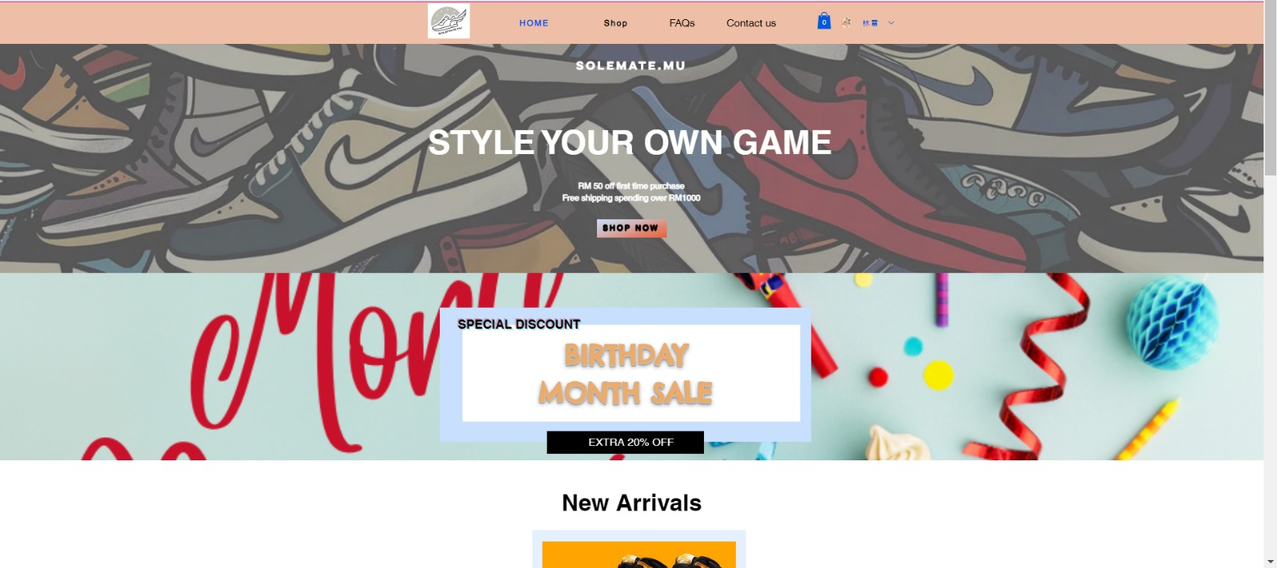

Figure 1: The home page of WIX website

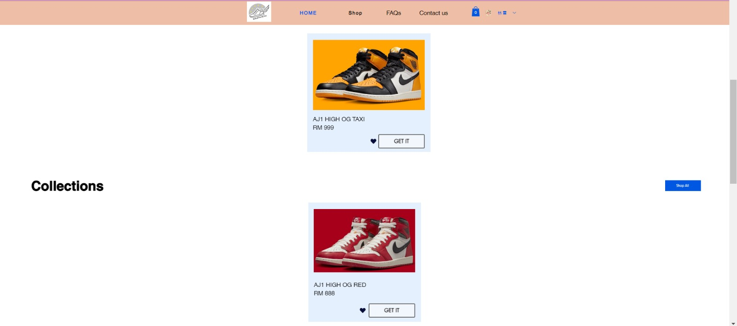

Figure 2: The New Arrivals and Collections of the products

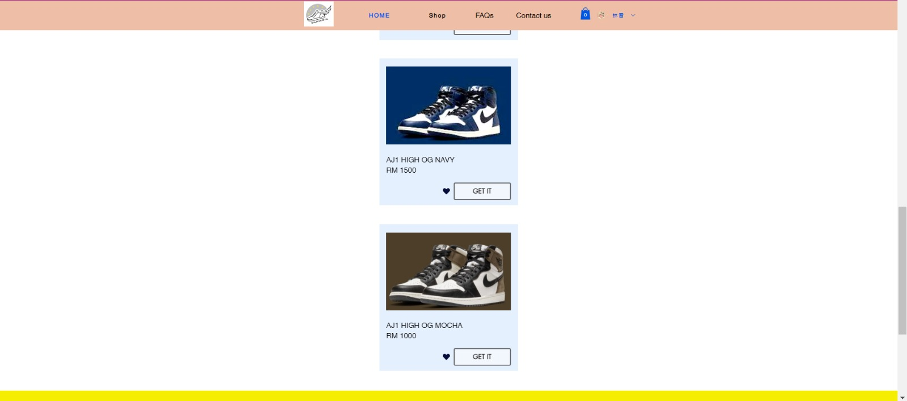

Figure 3: The Collections Sneakers

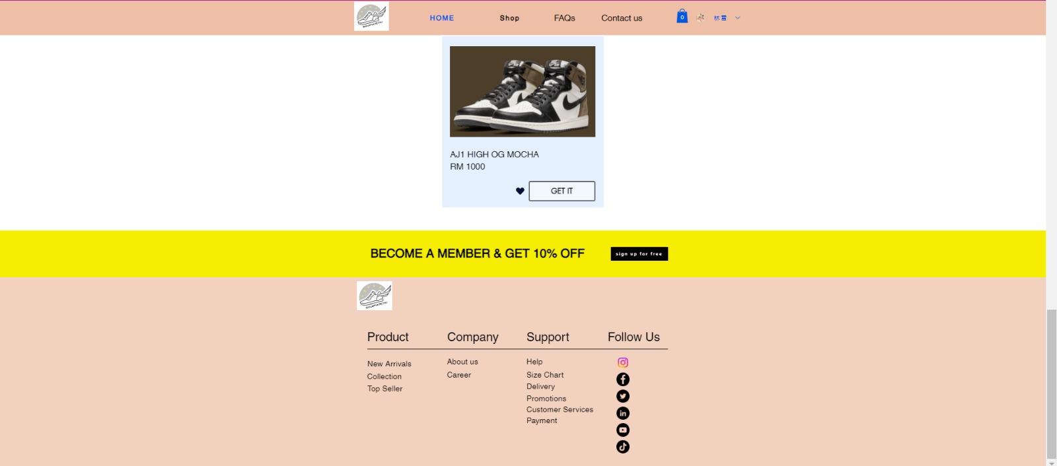

Figure 4: The Last page of the main page

When Click the word “Shop” at the top, it will link to the page that shown in below:

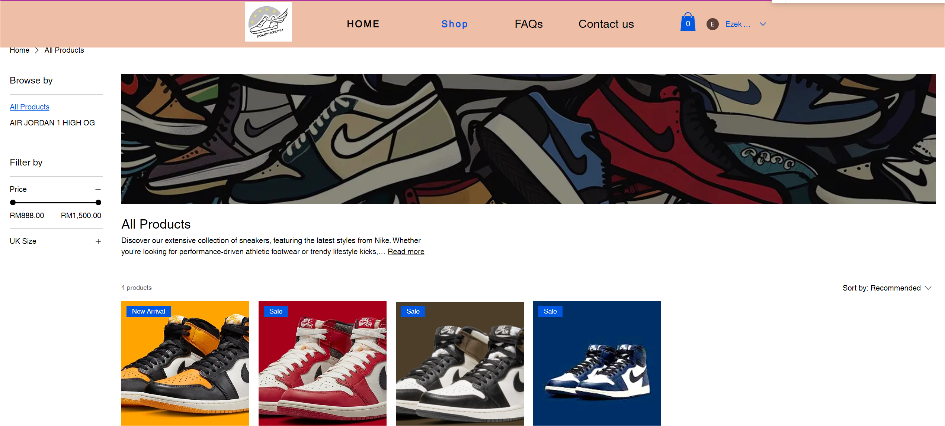

Can Click

Figure 5: The first part of category page

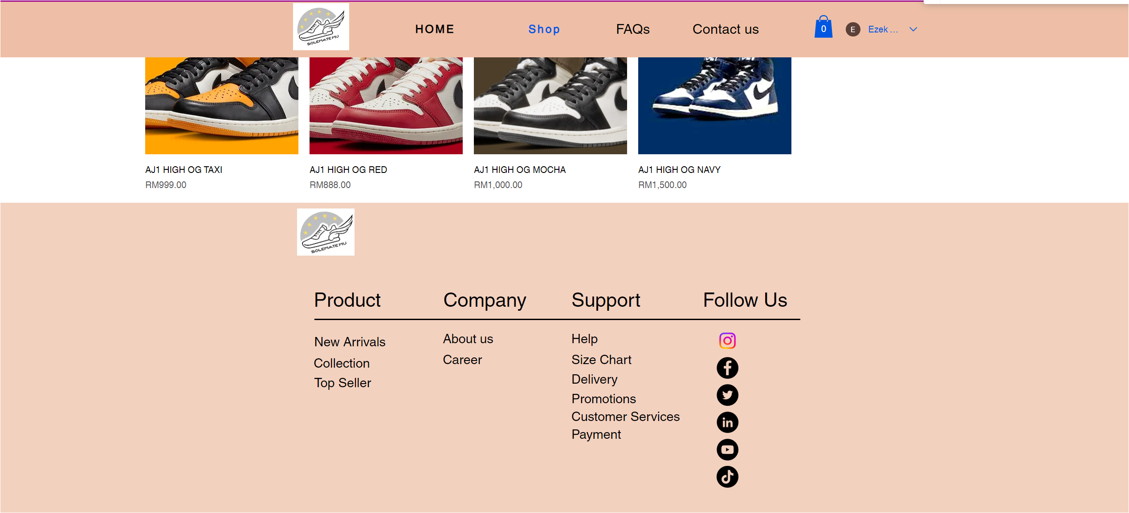

Can Click

Figure 6: The last part of the category page

When click on the product, it will link to the page that show the detail of the product as shown in below:

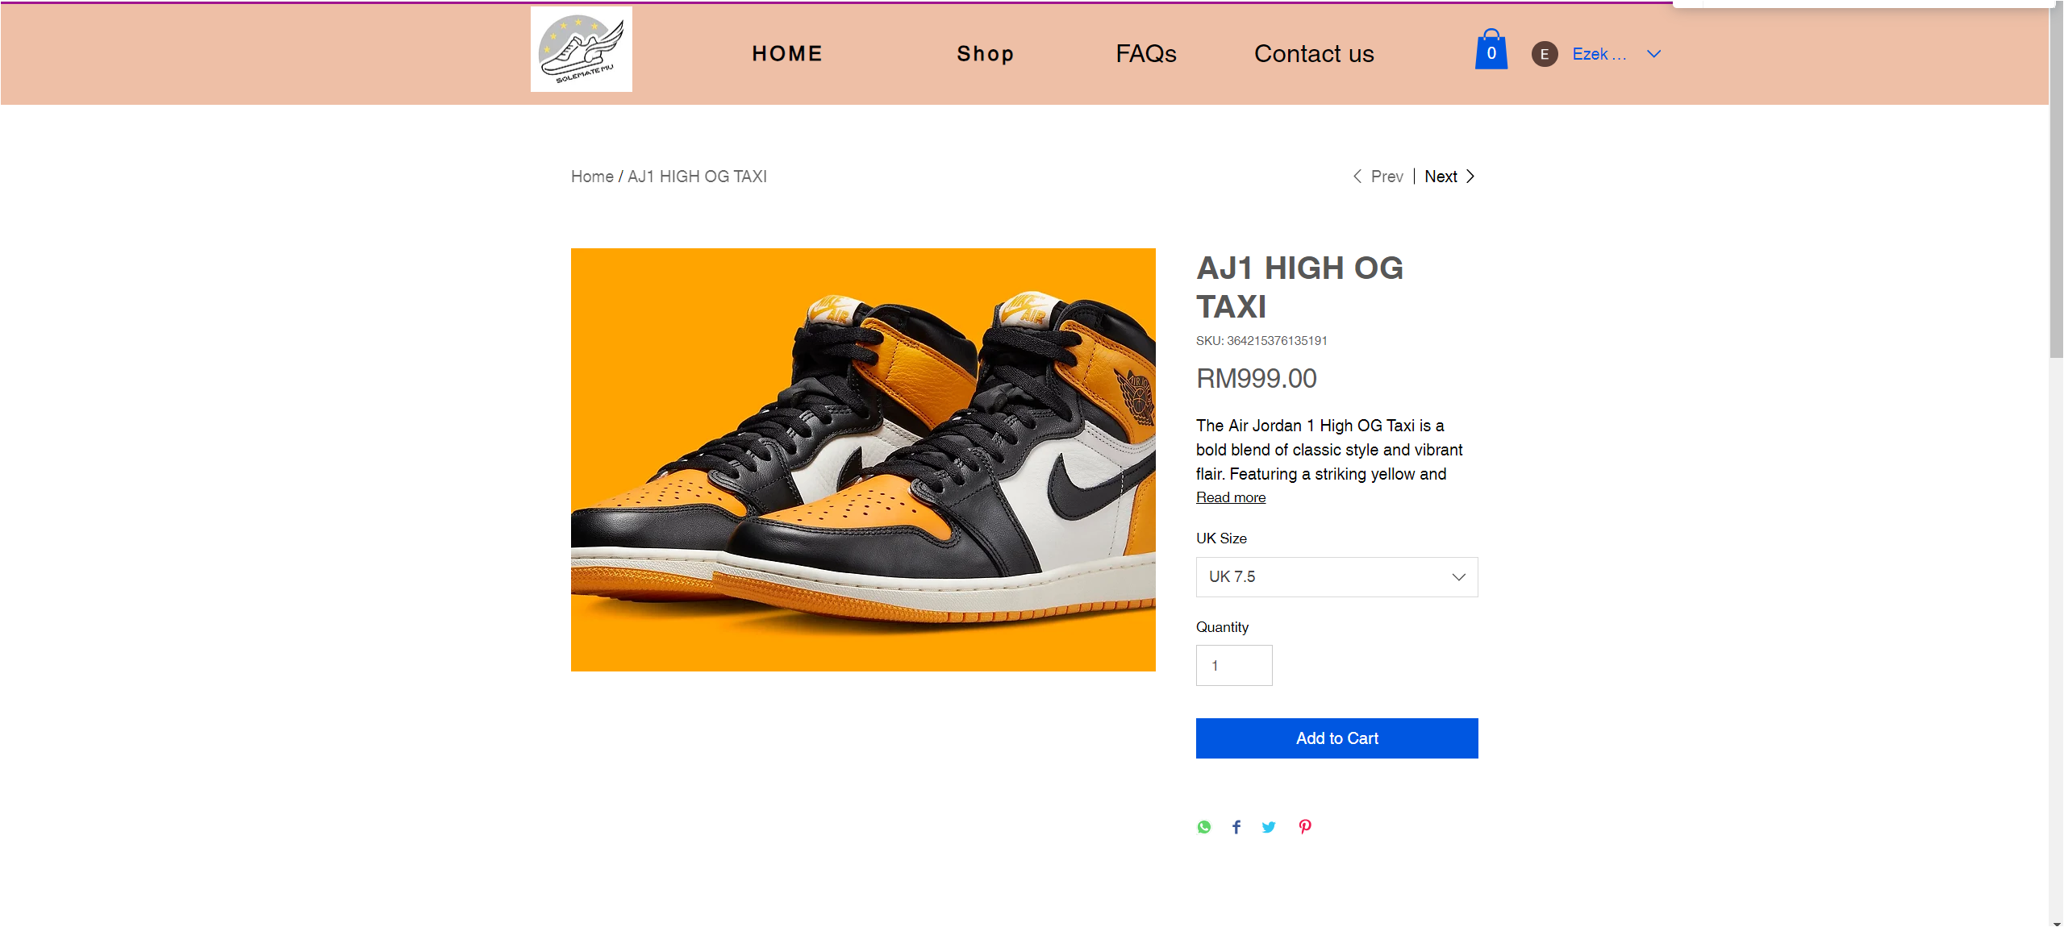

Figure 7: The First part of the AJ1 HIGH OG TAXI product page

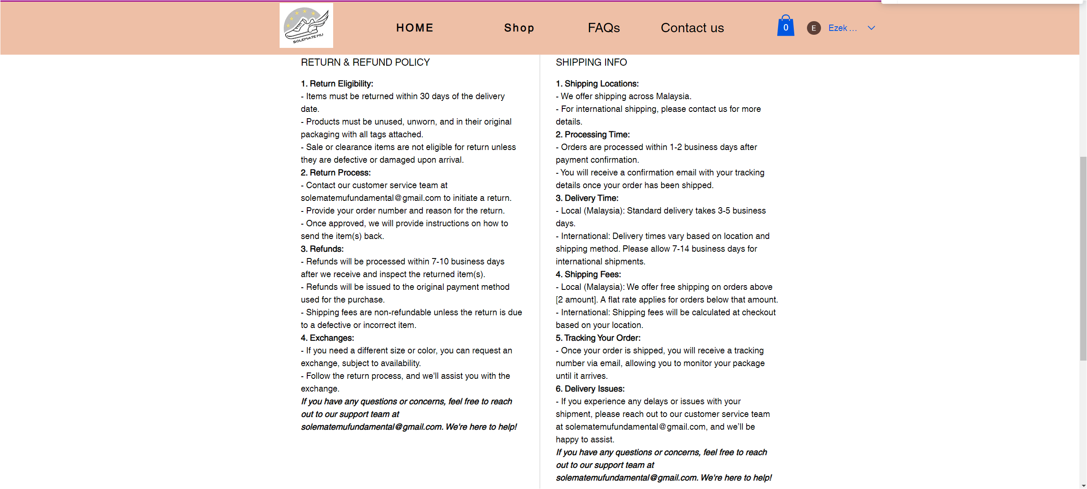

Figure 8: The second part of the AJ1 HIGH OG TAXI product page

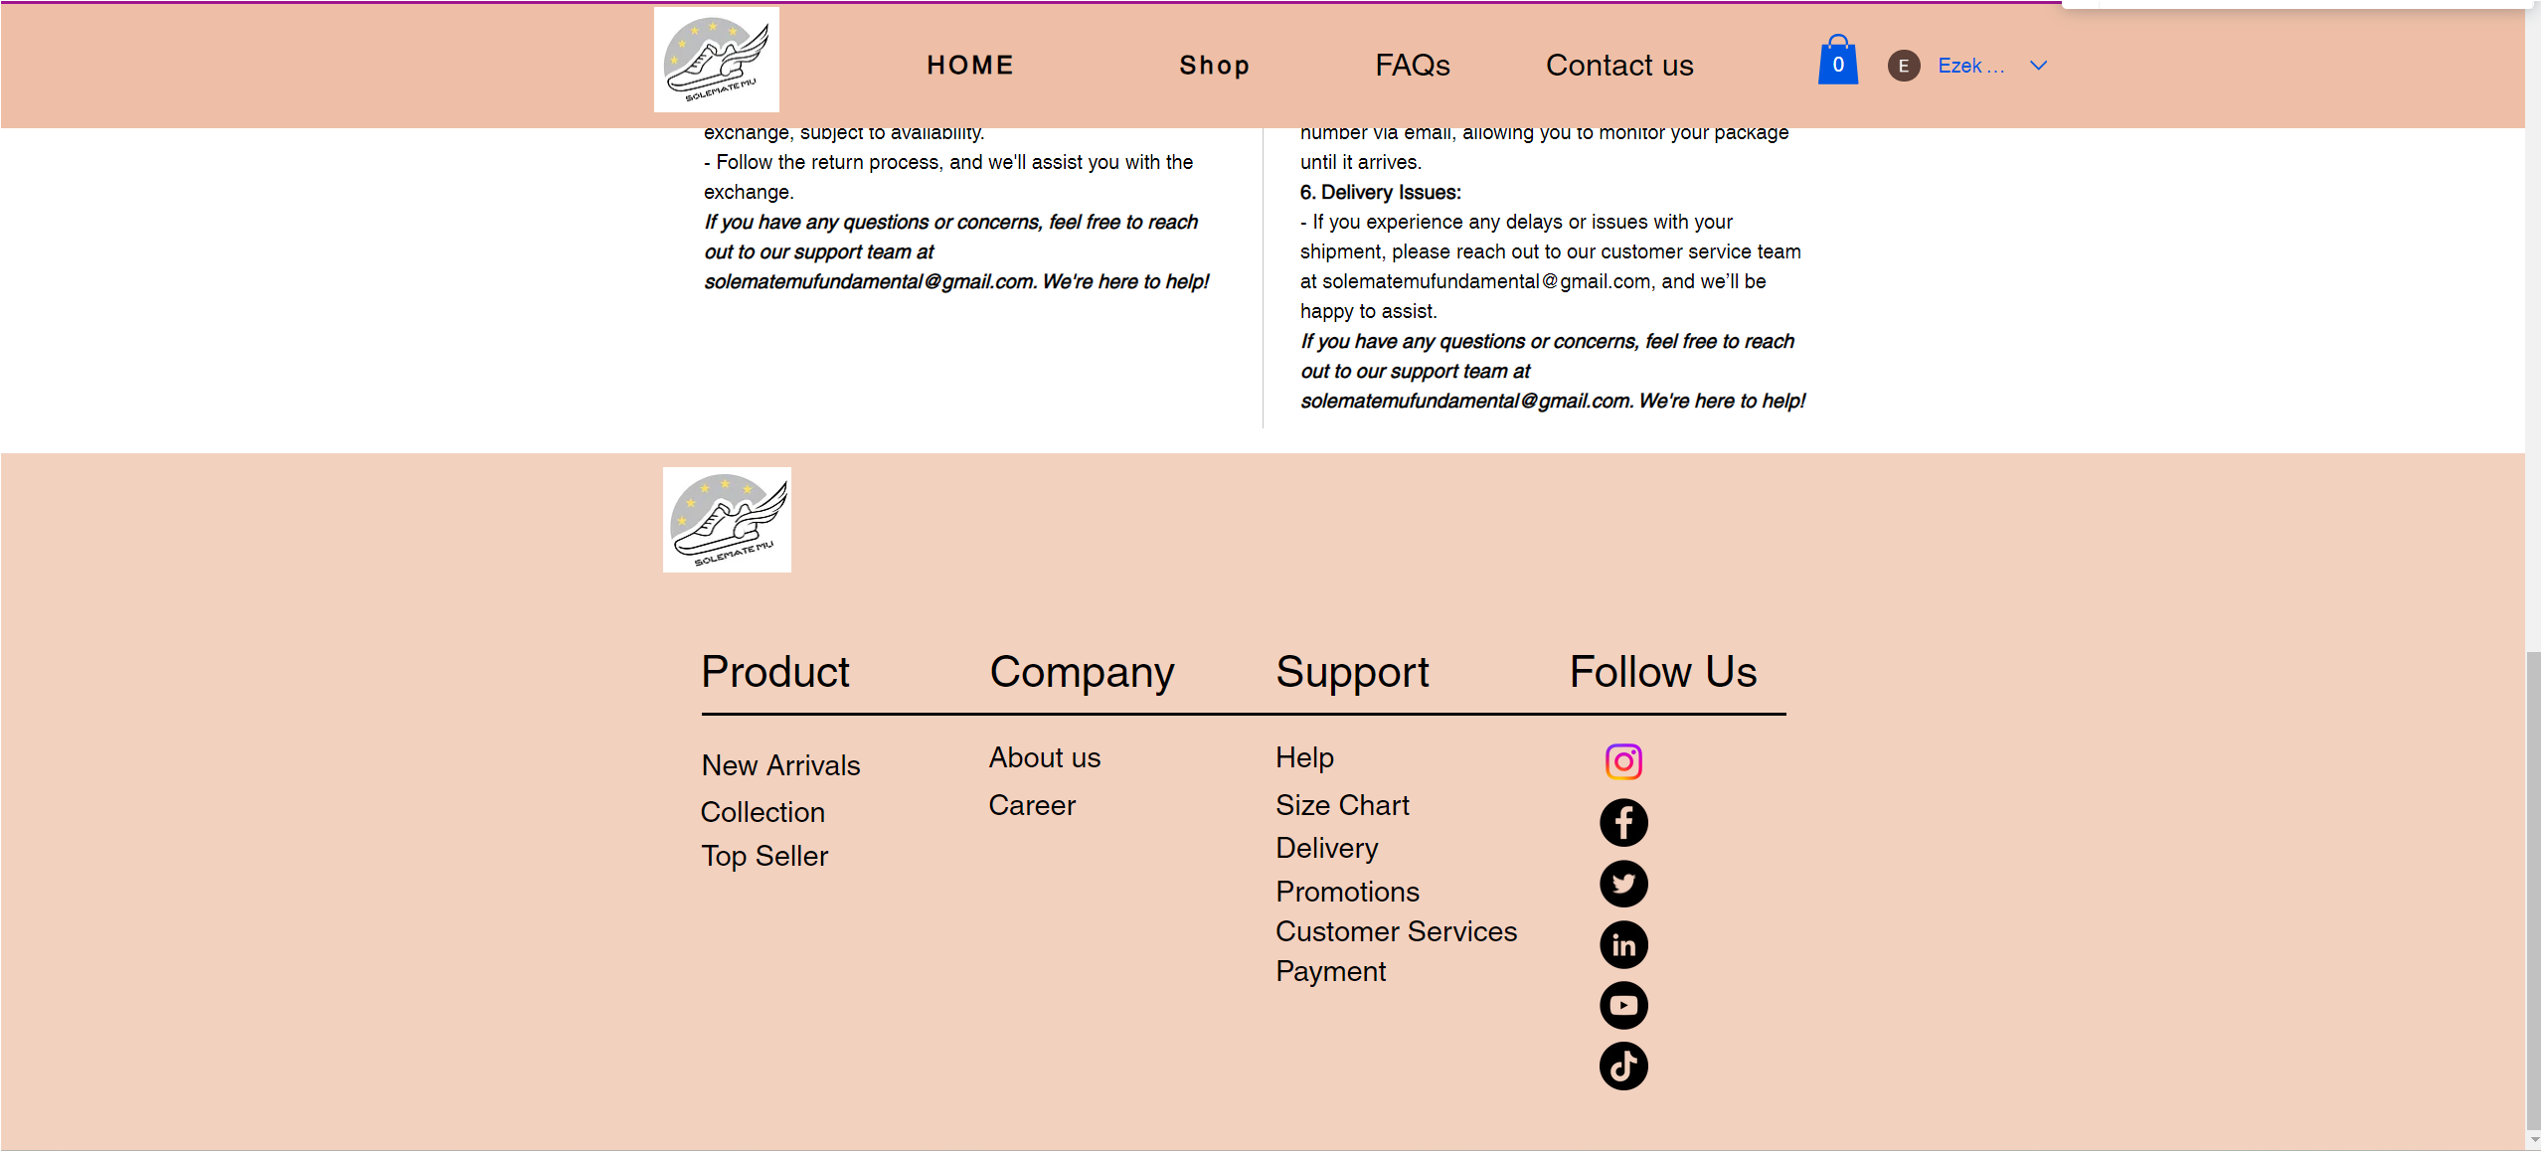

Figure 9: The last part of the AJ1 HIGH OG TAXI product page

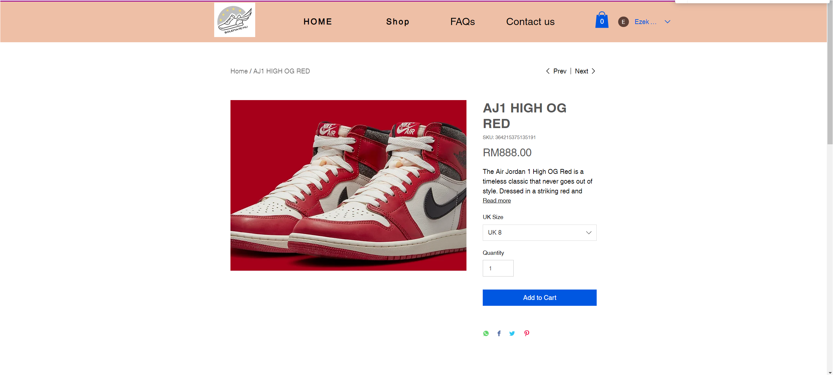

Figure 10: The first part of the AJ1 HIGH OG RED product page

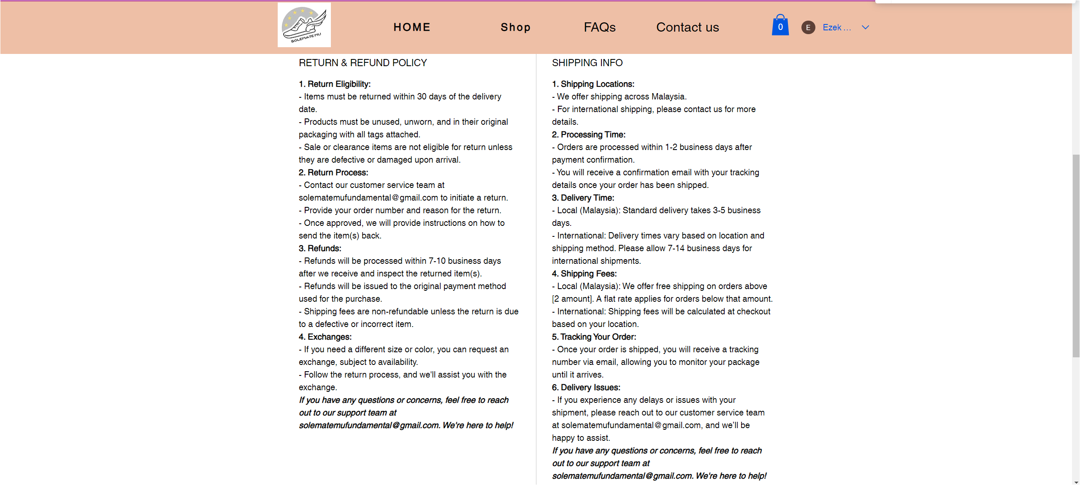

Figure 11: The second part of the AJ1 HIGH OG RED product page

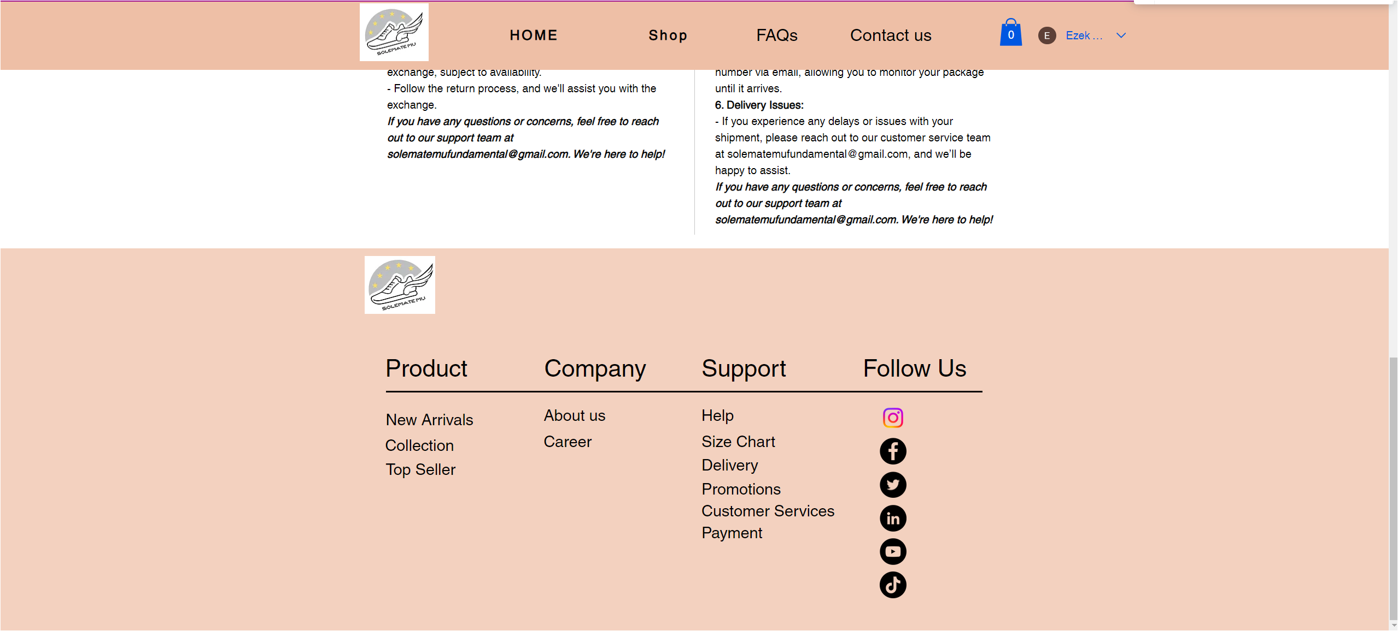

Figure 12: The last part of the AJ1 HIGH OG RED product page

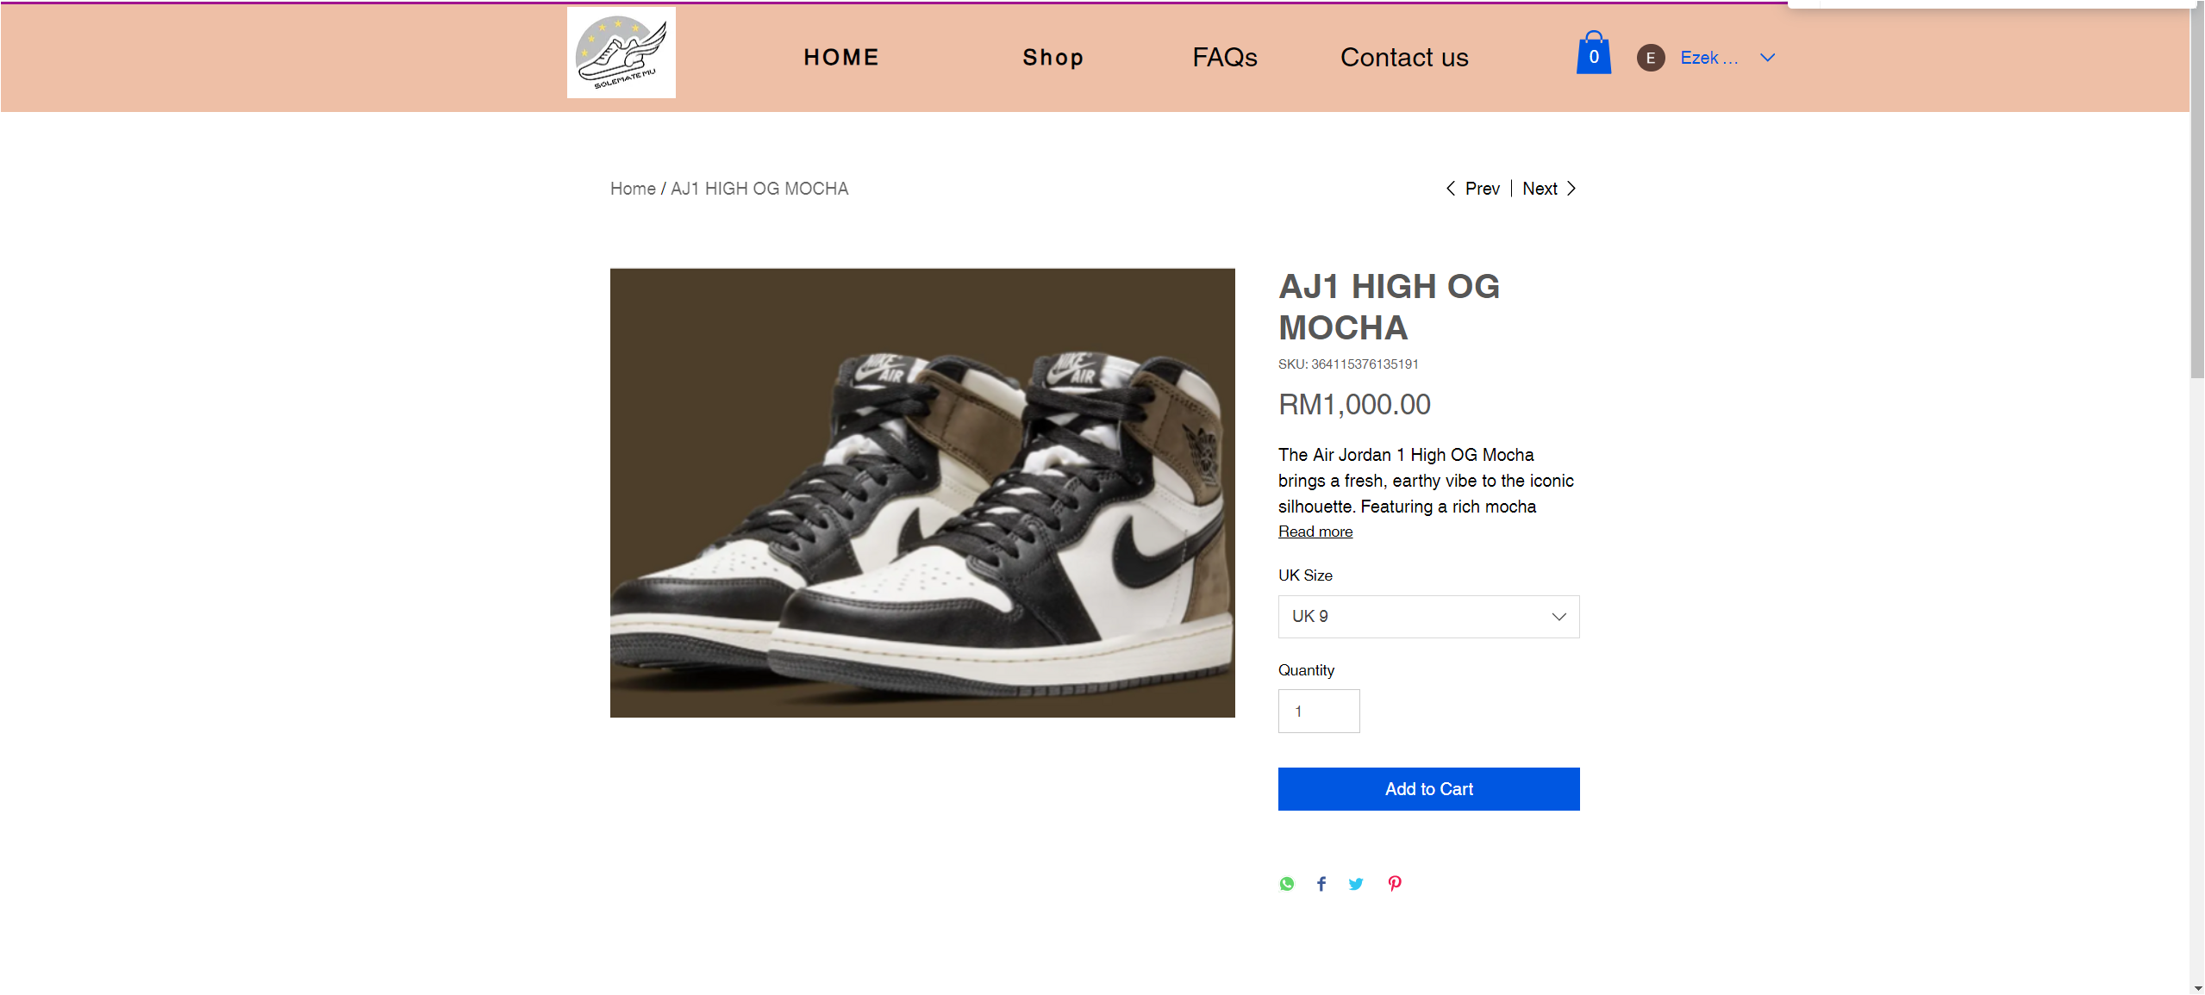

Figure 13: The first part of the AJ1 HIGH OG MOCHA product page

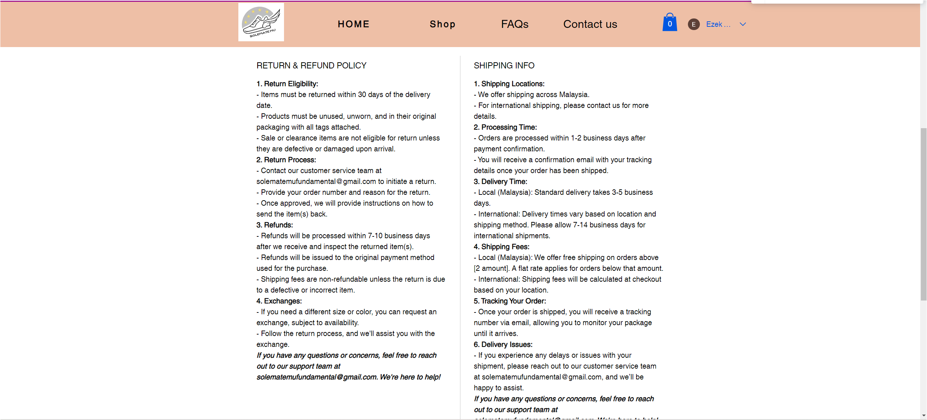

Figure 14: The second part of the AJ1 HIGH OG MOCHA product page

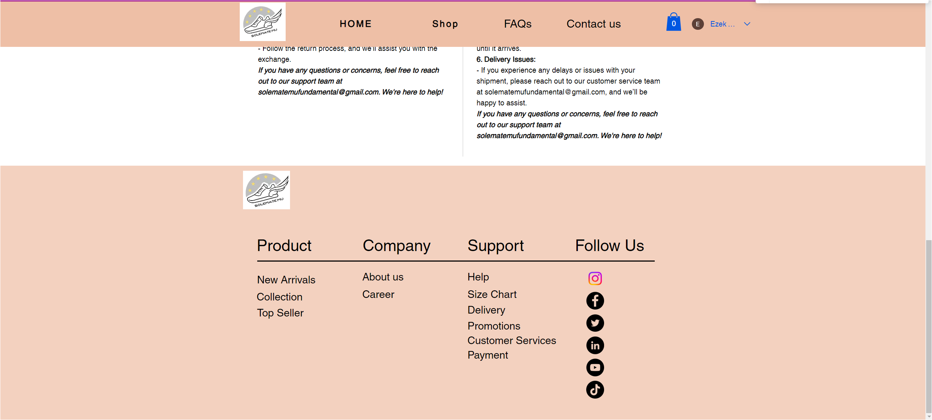

Figure 15: The last part of the AJ1 HIGH OG MOCHA product page

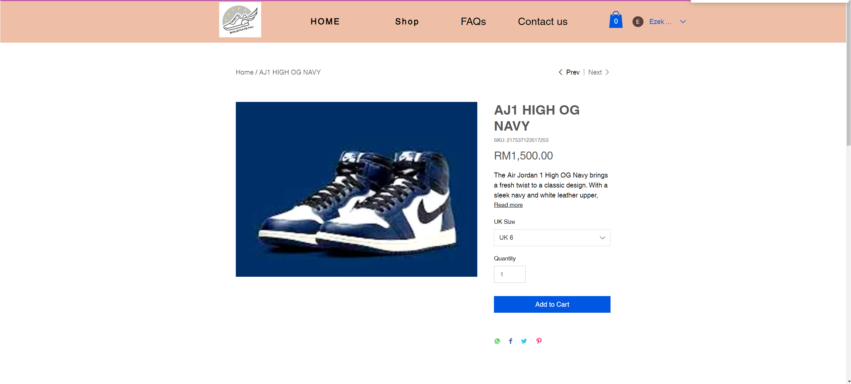

Figure 16: The first part of the AJ1 HIGH OG NAVY product page

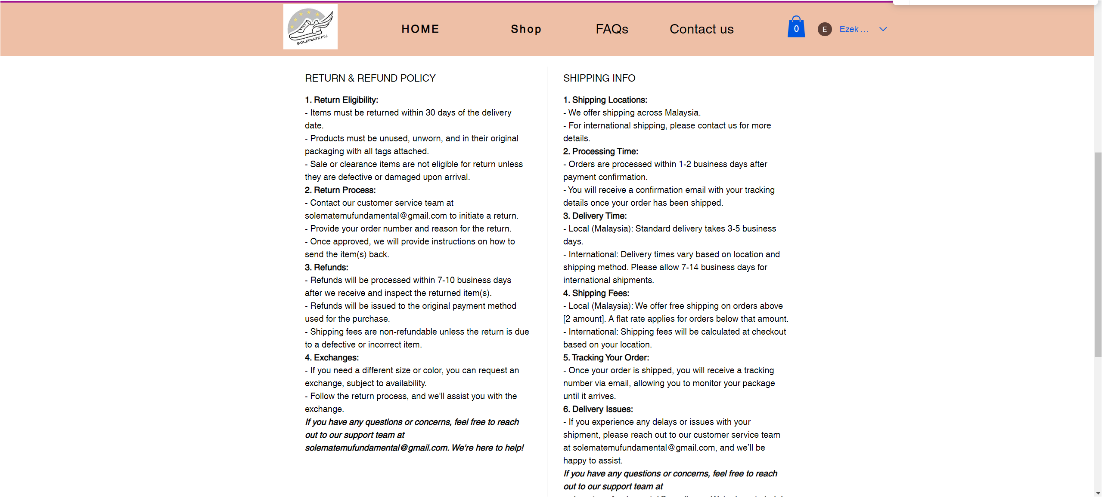

Figure 17: The second part of the AJ1 HIGH OG NAVY product page

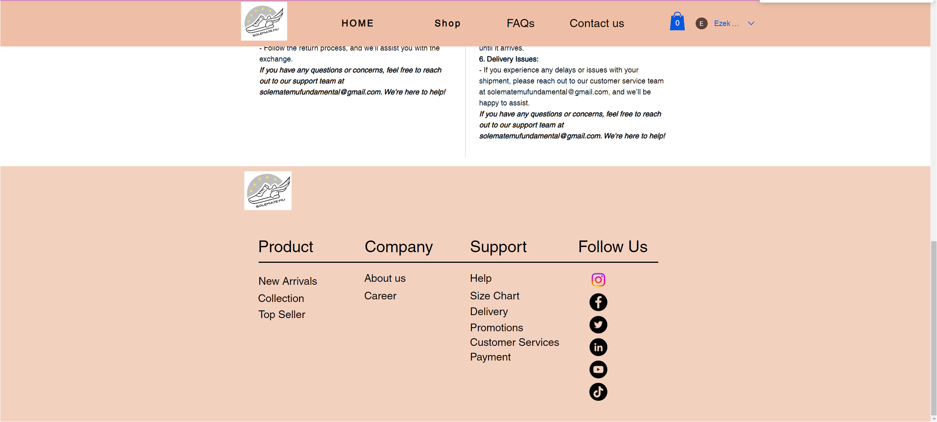

Figure 18: The last part of the AJ1 HIGH OG NAVY product page

# **Figma**

<https://www.figma.com/design/xkLQuSzxbJ04JBXSRHZaKI/Figma-basics?node-id=1669-162202&node-type=canvas&t=32EaFaFHiWvChi5j-0>

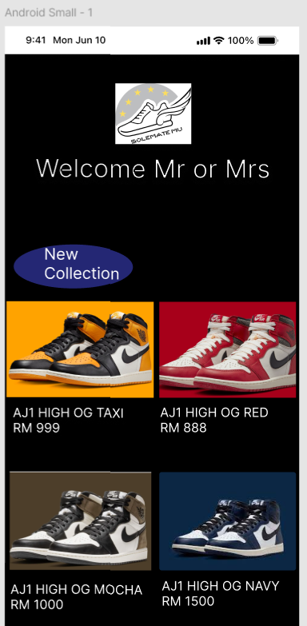

Figure 19: The main page of the mobile app

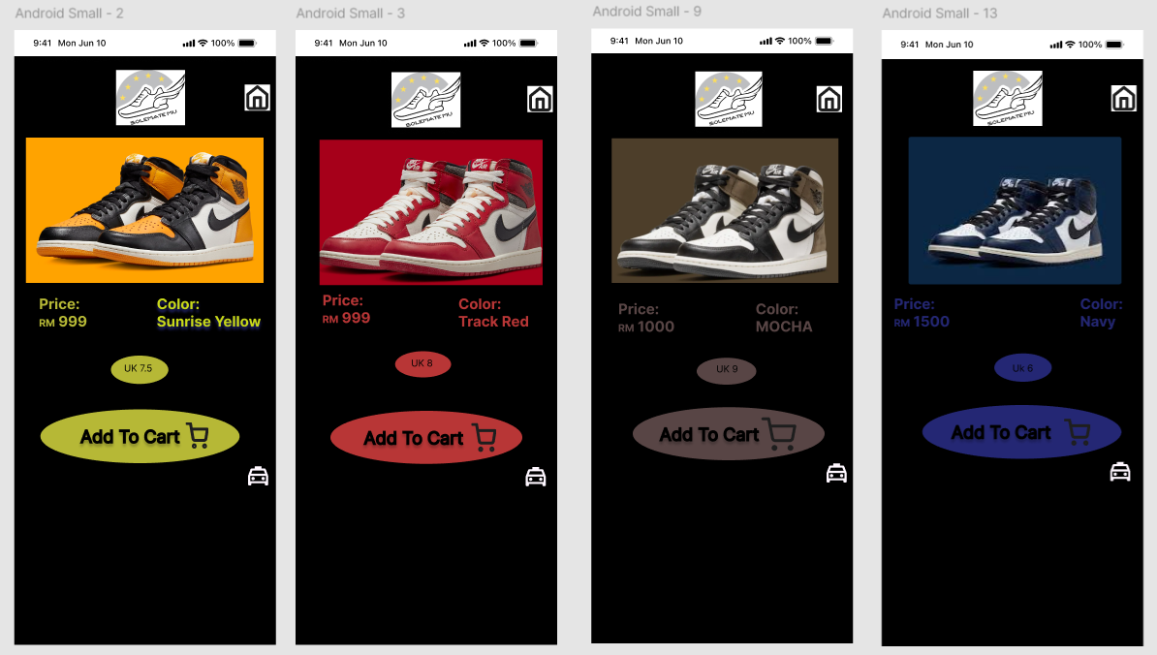

Figure 20: The product page will be show when user click on each of the product in the main page to view

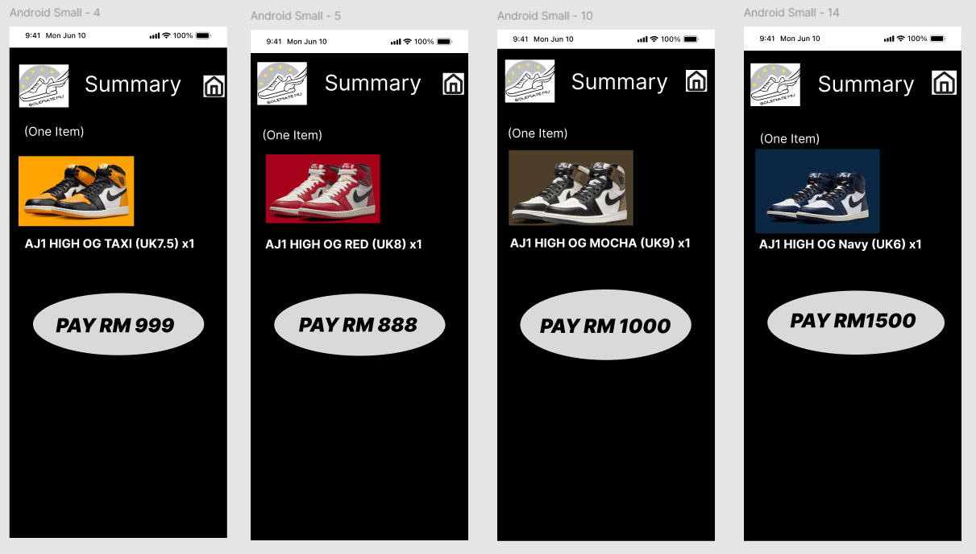

Figure 21: The amount of each product will be show when user click on add to cart

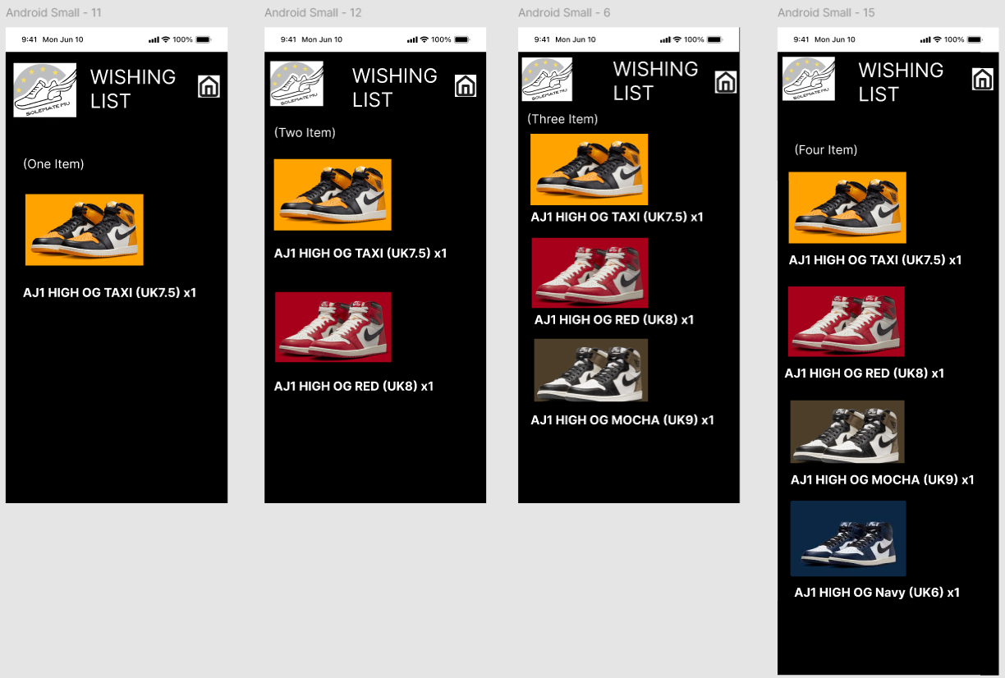

Figure 22: The wishing list of the user when click on the taxi symbol

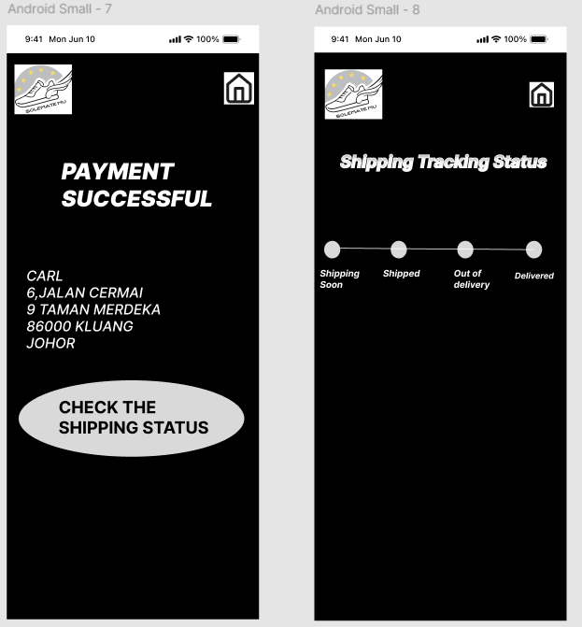

Figure 23: The payment successful and the shipping tracking status when user purchase the sneakers

# **User Manual**



Figure 24: Cover page of user manual



Figure 25: Introduction of the company

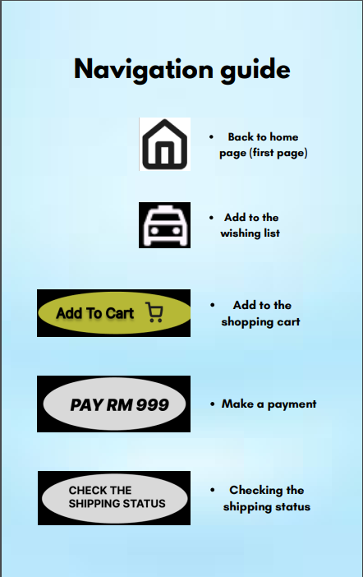

Figure 26: Navigation guide page of user manual

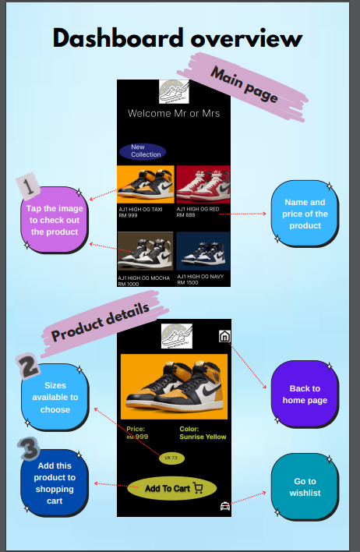

Figure 27: Dashboard overview 1

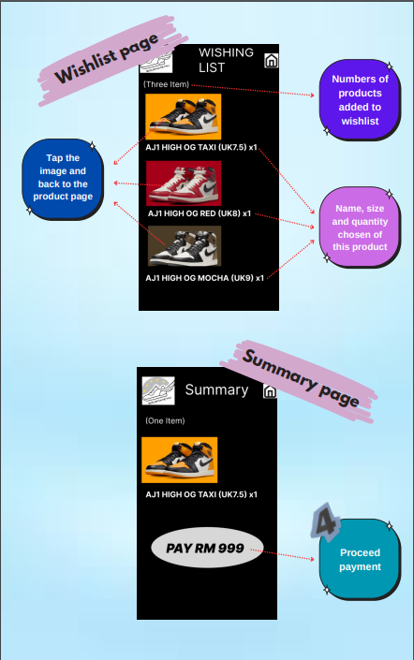

Figure 28: Dashboard overview 2

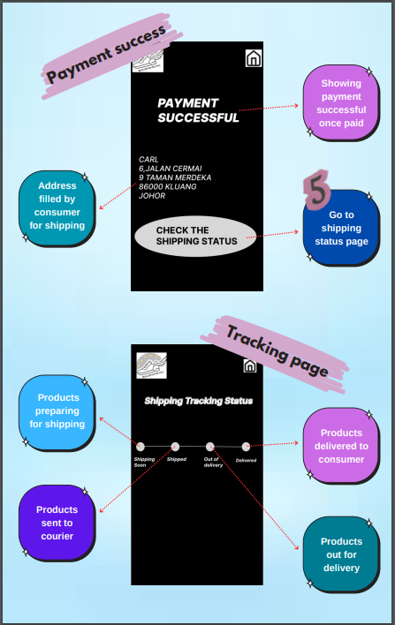

Figure 29: Dashboard overview 3

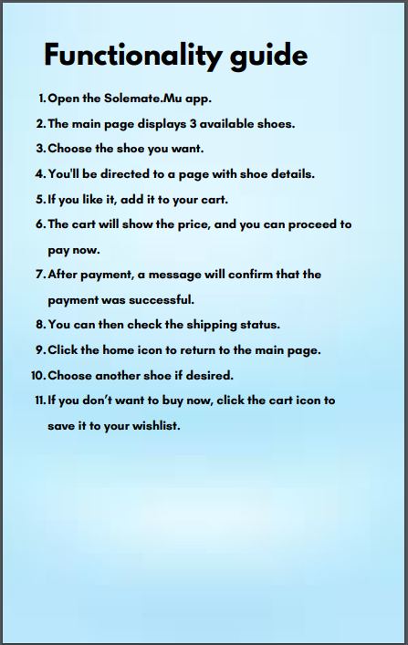

Figure 30: Functionality guide page



Figure 31: Visual design and branding page

# **Git and Github**

Members name in the github are:

|  |  |
| --- | --- |
| **Members name** | **Github name** |
| See Zi Ling | SeeZiLing |
| Teo Min Hui | 7TEO |
| Lum Yong Kai | YongKai66 |
| Tan Lee Jin Xiang | JordenLJX |
| Yeo Chang Yong | Ezek Yeo |

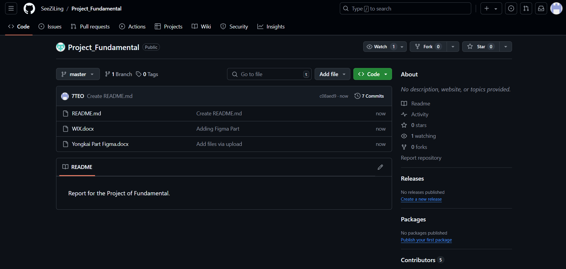

Figure: 32: The repository and README that created for the project

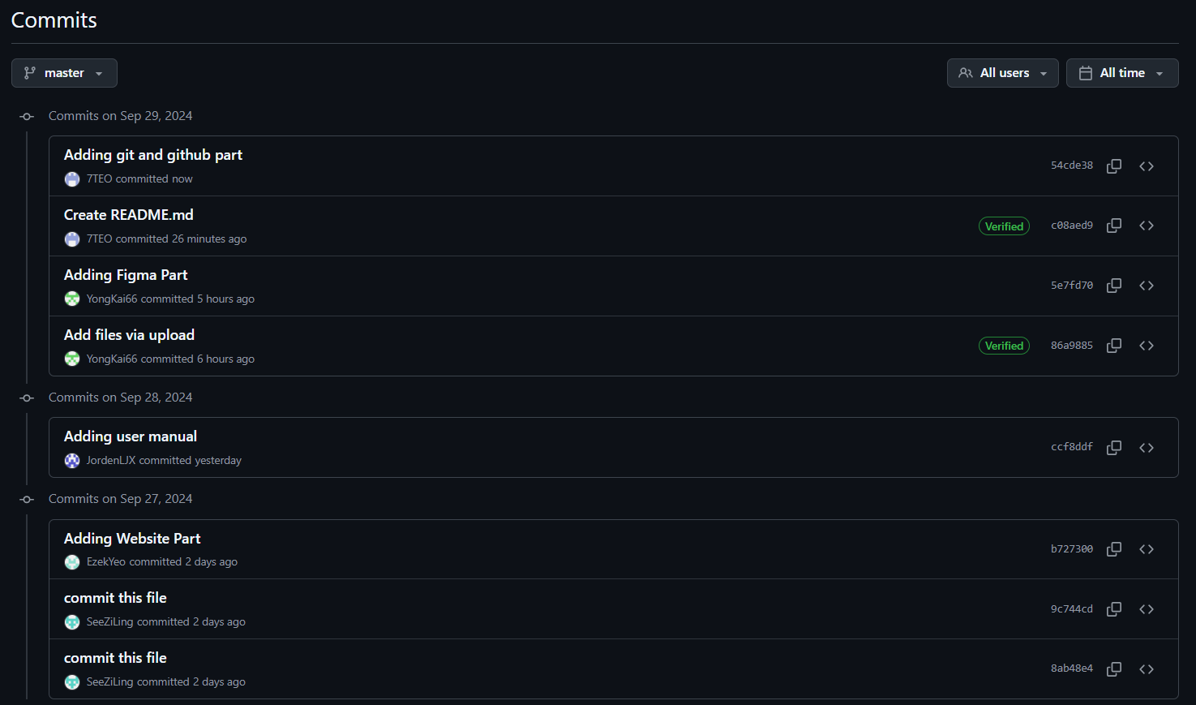

Figure 33: The history of each members modified and uploading the file into the github

Leader uploading the first file in Github as shown in below:

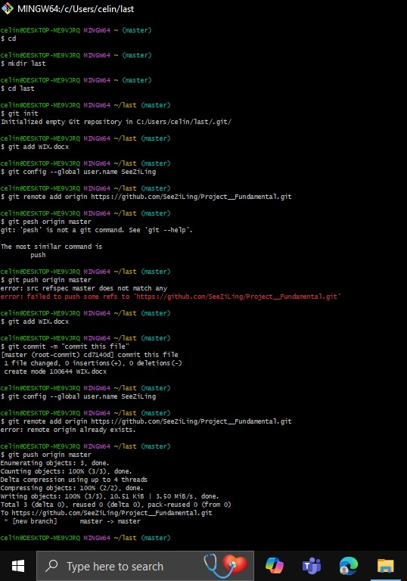

Figure 34: Code that done by See Zi Ling (Leader)

Each member combine and upload the file using the branch code method.

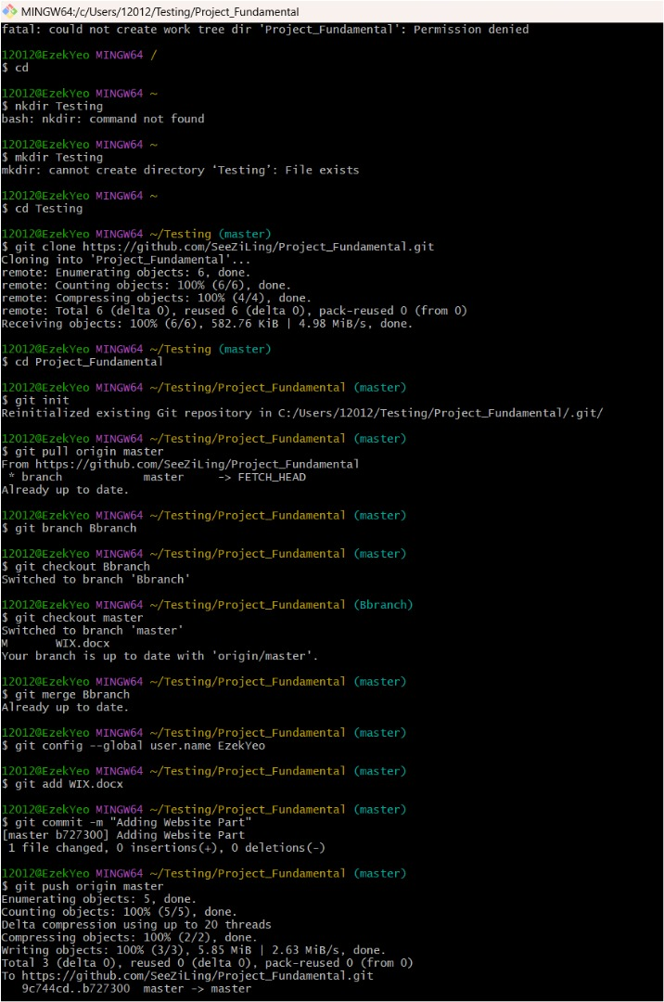

Figure 35: Branch Code that done by Yeo Chang Yong

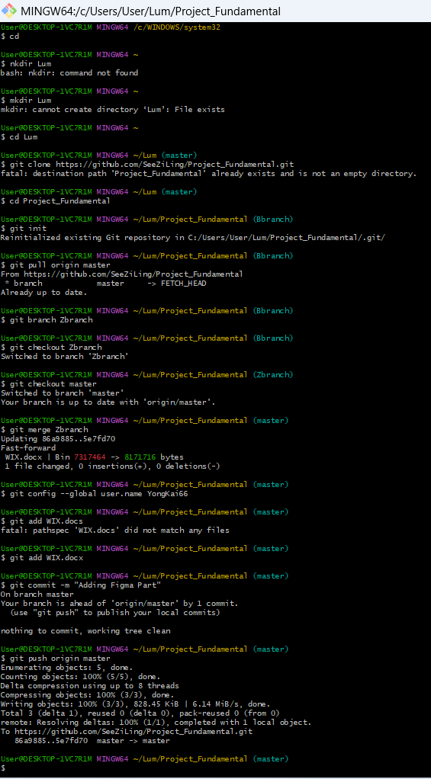

Figure 36: Branch code done by Lum Yong Kai

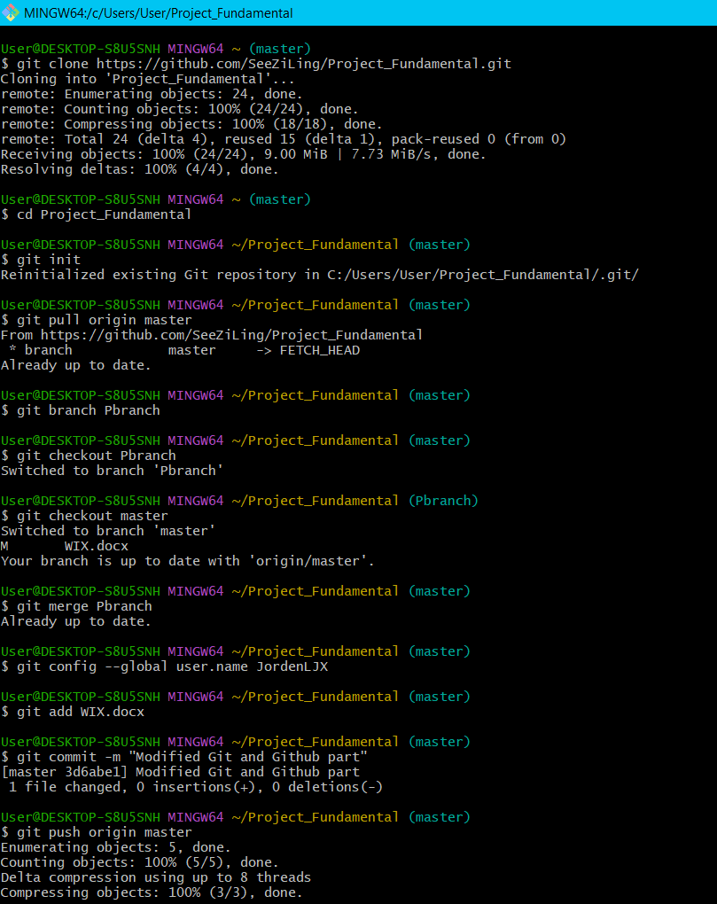

Figure 37: Code done by Tan Lee Jin Xiang

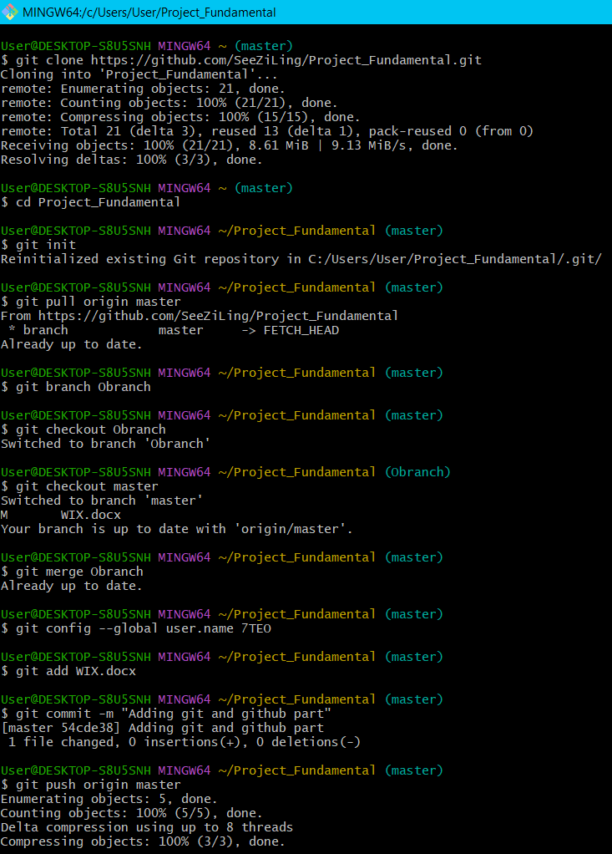

Figure 38: Branch code done by Teo Min Hui